**Why control holly and cherry laurel?**

Holly forms dense stands, displaces native plants and changes the environment in which it grows. The deep shade created is unsuitable for native plants to germinate, resulting in loss of the ground layer. The red berries are spread by birds so they can travel far and wide. Often holly can be found under a favourite roost tree or bush. Holly also provides a prickly shelter for rabbits, foxes and starlings. Once holly plants get established, they send out branches which layer, touch the ground and send out new roots, creating a thicket. Holly is dioecious so individual trees are either male or female. This is why not all holly bushes have the red berries, but it is important to remove both.

Cherry laurel has similar characteristics and impacts on the bush as holly. It is multi-stemmed with large, leathery oblong leaves. It flowers in summer and produces cherry-sized berries which ripen from green to purple-black into autumn. Birds love the seeds and spread them.

The following steps are recommended for controlling these weeds:

*Planning*

Planning the treatment steps is important. Survey the whole area to identify actively seeding trees and treat these first. Then start with the small outliers, gradually working in towards the most heavily infested area. Choose the control options to suit the infestation (see following options). Hiring a contractor is great for large thickets; work with the contractor to plan the priority sites or plants. For example, use the contractor and their specialist equipment to spray large plants to stop seed onset and to chainsaw and paint medium sized plants. Then “mop up” smaller plants yourself or with fellow weedies. Working with your neighbours is effective and fun!

*Breaking the cycle*

For a temporary fix, remove any berries into a bag and burn them in the fire. Ideally, remove berries into a bag from any cut branches or stems. Cut branches or stems may be spread out to dry off the ground. When dead, this material will decompose in place, or may be composted. Placing branches in the one spot makes it easier to control any seedlings that may germinate, particularly if the berry load is too large to remove.

*Follow up*

Is critical to success, go back after a year. Scout around for fresh seedlings and reshooting roots and re-treat. Look in densely shaded and moist areas. For mature sprayed trees, there should be a lot of dead foliage and bare stems, if your first go was successful. The bare stems now make it easier to access trunks and branches that may have been missed the first time. Follow up again the following year.

*Replacing the weed*

If you are removing holly and cherry laurel from your garden, there are many wonderful resources to help with choosing a replacement - check out your local Gardens for Wildlife or Landcare websites for ideas.

**Specific control options for holly and cherry laurel**

***Mechanical*:**

Cutting the plant without follow up treatment will not work because it suckers and coppices (grows multiple shoots from the stem once cut).  Leaving fragments of root or stem can also allow the plant to regrow. Small seedlings may pull out of damp soil but you need to remove all the roots. Grazing animals such as goats may be effective in some locations but it is best to consult a goat specialist as fences, water etc are important animal welfare considerations.

***Chemical:***

*Spraying*

Both plants have shiny leaves so spraying with herbicide (such as 340ml/100li Triclopyr 600 (eg. Garlon) plus 10g /100li Metsulfuron 600 (eg. Brushoff)) requires a mix with a wetting agent (such as Pulse). Spraying is useful for stopping flowering and seed formation, particularly on large plants. Leaves will eventually drop off and, if the main stem is still alive, it can be treated after two years using the cut and paint method. Any seedlings carpeting below a large plant are likely to be killed by the spray. If there are many small seedlings in the area, this option is useful too. However, be careful not to spray non-target species if working in the forest.

*Cut and paint*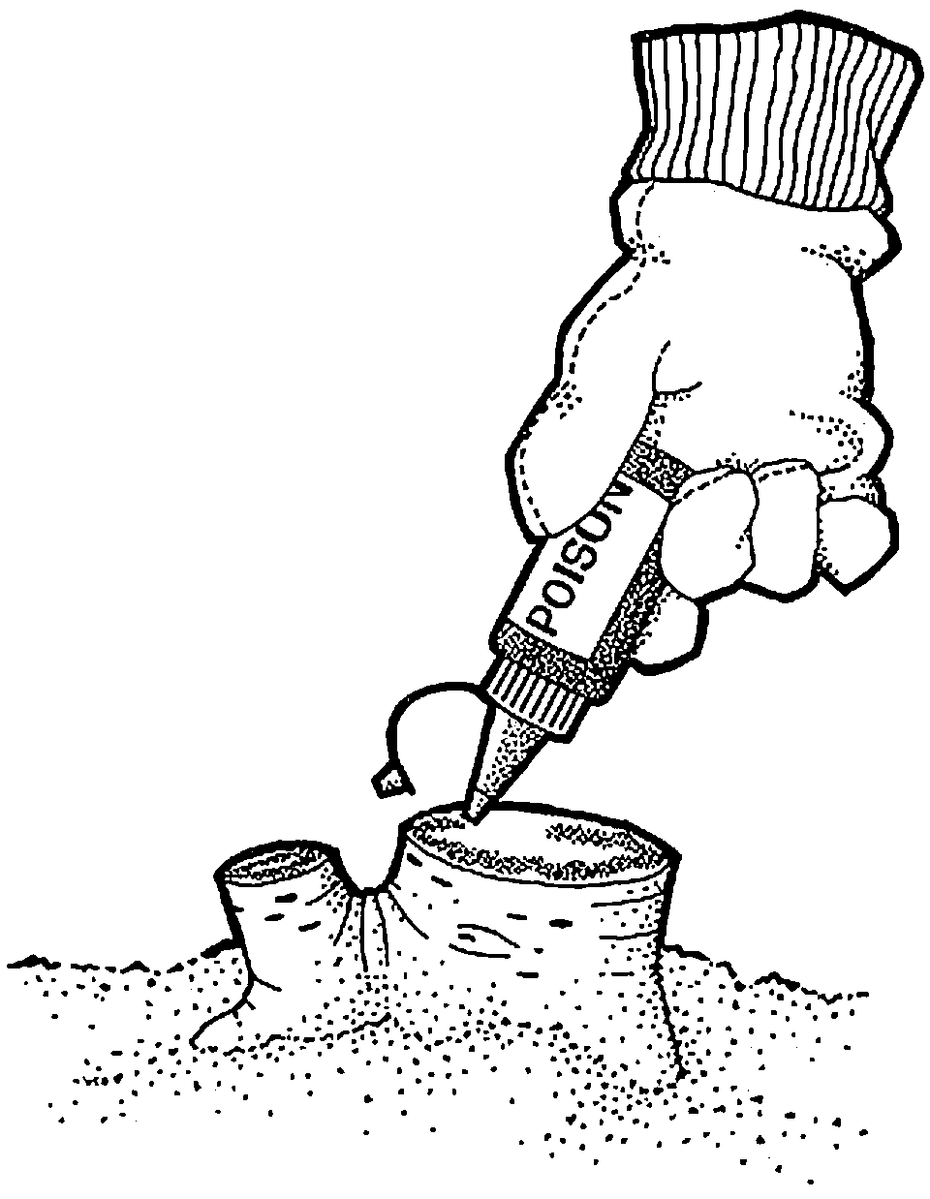

Carefully and immediately (within 15 seconds) apply concentrated herbicide using an applicator bottle on the cut/scraped area. This may be easier working with a second person - one cutting, one painting. Use a full-strength herbicide (such as Glyphosate) with these techniques. Do not allow the surface to get covered with soil.

Juvenile plants, roots and ‘touchdowns’: scrape and paint, making sure that you scrape at least 1/3 of the length of the stem, root or the layered touchdown plant.

Small plants: Make a horizontal cut as close to the ground as possible with secateurs or loppers, and immediately apply concentrated herbicide to the exposed stump surface.

Larger plants: Cut and paint each main trunk over the whole of the cut surface. Scraping a minimum of two sides and painting immediately may also be sufficient.

Very large plants: For any plant with a stem diameter of 40 mm or more at the base, lop off the top half if possible. Use a strong pruning saw or a chainsaw to remove lower branches to access the trunk, then cut with the chainsaw as close as possible to the ground. Paint immediately with neat herbicides.

*Stem injection and frilling*

The stem injection technique on larger holly has been found to blunt drill bits rapidly. However, the technique is useful in situations such as beside a road where it would be dangerous to drop the small tree, or if a bird’s nest has been seen within the branches. By the time the tree has died, the birds will have departed.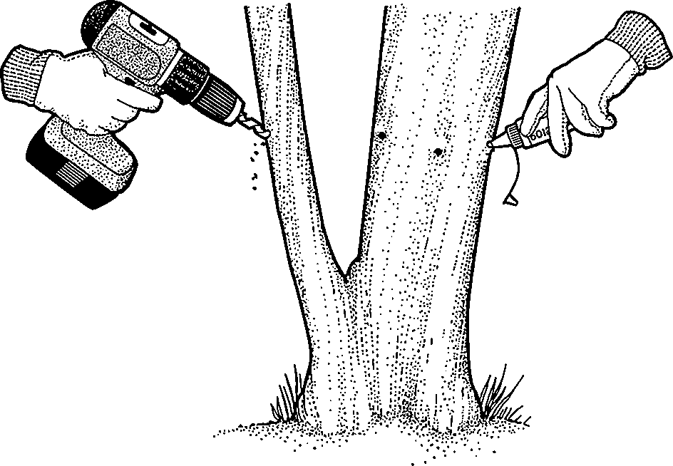

At the base of the tree, drill holes at a 45° angle into the sapwood (just under the outer bark, maximum 1 cm deep) at two finger space intervals around the entire base of the tree. Repeat this process below the lowest branch. Alternatively, remove lower branches of larger plants to 1–2 m from the ground and then stem inject herbicide up to the pruned level. For plants taller than 2.5 m, either lop off the top half or inject a second ring about half way up.

Frilling as an alternative to drilling: make cuts into the sapwood with a chisel or axe. Fill each cut with herbicide immediately. Repeat the process at 3 cm intervals around the tree.

Use a full-strength herbicide (such as Glyphosate) with these techniques.

***PPE:***Use gloves, mask, hat, safety vest, and sturdy boots. Holly is prickly so best to wear long sleeves and full length trousers. Follow additional precautions in safety manuals if using power tools. Follow herbicide label instructions.

**Record your sightings of holly:** Download the iNaturalist app to your phone and upload photos of holly you see in the area. This will help with future control efforts.

**For further information** please contact

The Holly Project [weedcontrol200@gmail.com](mailto:weedcontrol200@gmail.com)